New Life Baptist Church would like to extend an invitation to the members of LCA. Whether you are looking for a church home or just want to join us sometime, NLBC welcomes you.
Church Services: Sundays, 9:30am/6pm, Small Groups, 10:45am. Wednesdays, 6:30pm
Current Preaching Series: The Gospel of John, Sundays. Lamentations, Wednesdays.
Children's Program: 6:30pm, Wednesdays.
For more information and details on our beliefs, visit www.nlbc-harvest.org.
Soli Deo Gloria!

LCA Newsletter – Week 7, Spring 2019
Welcome to the LCA newsletter! If you have any information you feel your LCA family should know about – send it my way! Krista.s.hahn@gmail.com. Have a blessed week! ~Krista Hahn

Attention Please!

Re-enrollment February 15th - March 15th
The time to reenroll for the 2019-20 school year is NOW! This year our reenrollment period is February 15 to March 15th, and the process will be different than previous years. Every current LCA family has a re-enrollment packet waiting for them in the LCA office. Please come by and pick it up. This packet has all the forms you need as well as the DRAFT of next year’s classes!
Report Cards & Teacher Fees are OVERDUE!

Testing Change Requests Due AND Volunteers Needed!
If families want to make a change in their testing request to please contact Robyn ASAP at robyn.schrock@nlbc-harvest.org. Also, if folks want to volunteer to help with testing and haven't yet they may still sign up.
ACT Registration Due!
The ACT testing at LCA is coming up on Wed, Feb 20 from 8-12. This is for 10-12th grade students who are full time or part time members. Pre-registration to Robyn Schrock is needed. Optional pre-administration sessions for filling out surveys and college choices will be Thurs, Feb 14 at 3:30pm OR Tues, Feb 19 at 2:30pm or email Robyn
(robyn.schrock@nlbc-harvest.org) college choices. Fee is $50 payable to LCA.

Science Fair, NARSEF, and Science Night
Science Fair: Life Christian Academy will be having our annual science fair for our students (all grades) at LCA on March 4th. Participants should come that evening prepared to present their projects and everyone should plan to follow procedures which can easily be found using a Google search. For example:
https://www.sciencebuddies.org/science-fair-projects/science-fair or http://www.sciencekids.co.nz/projects/thescientificmethod.html
Please contact David and Suzie Nance at 256-653-2508 or drnance@hiwaay.net for more information, to sign up to participate in the LCA science fair or to help out on the evening of the 4th. Also, let us know if you plan to be involved in NARSEF (details below).
NARSEF:
We have reserved spots* for the NARSEF (North Alabama Regional Science and Engineering Fair) competition held at UAH on March 12-13 so 5th through 12th grade students preparing for that should visit the website for rules, guidelines and forms: https://sites.google.com/a/uah.edu/narsef/home
*We have 2 spots for 5th graders, 2 spots for 6-8th graders and 2 spots for 9-12th graders reserved. Please let us know soon if you would like one or more of those spots.
The following dates should be noted for NARSEF:
Student Registration Begins | - | January 18
Online Project Registration Deadline | - | February 12
Paperwork Submission Deadline | - | February 15
NARSEF at UAH - March 12-13

Science Night:
On the same evening (March 4), LCA’s high school chemistry and physics students will set up demonstrations for parents, other family members and friends to view. There will also be an egg drop activity! Please invite others who may be interested in our science classes at LCA.
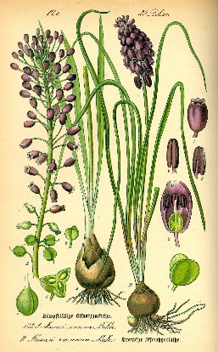
Huntsville Botanical Gardens - Classification of Living Things - Field Trip
March 4 @ 9:45 until 12:00
Cost $8 for children & $9 for adults
Ages 1st through 6th grade
We will be touring the garden and working in the classroom. We will be learning about how living things are identified and grouped and we will be visiting with some of the gardens live animals as well. RSVP by March 1st to Lori Donatelli 256-797-5952.
Lindsay Lane Fine Arts Competition:
Lindsay Lane Christian Academy will be hosting its 2nd annual Fine Arts Competition. The competition will be held on May 3rd, 2019 and is open to 4th – 12th graders. Please check out https://www.lindsaylanechristianacademy.org/art-competition for more info and registration forms. Students must be registered by March 3rd, 2019.
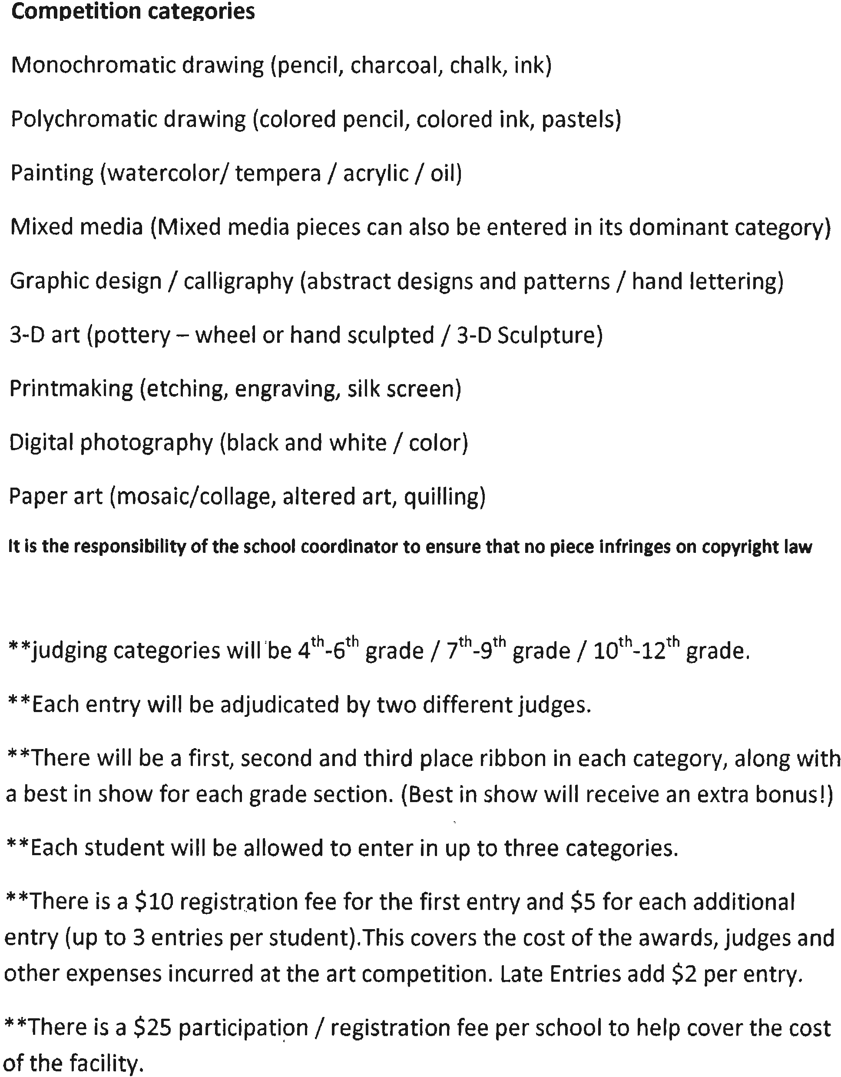
Chattanooga Aquarium Field Trip
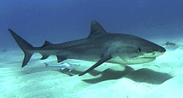
When: March 20 at 9:15 Cost is $8 per student and $24.50 per adult. A special creature encounter has been scheduled for our group at 10:00. We must meet in the front lobby of the aquarium by 9:15. A school lunch or imax ticket is available at an extra cost but you must register for them by March 4th. To register for the trip please contact Pamela Hereford (pamelahereford82@gmail.com).

LCA Fieldtrip to James Clemons Theatre
APRIL 10 at 9:00am
$5 per person
Please turn in an envelope to Jennifer Funkhouser’s box by Feb 22th with your name, ticket number, phone number, and the money for your tickets (checks made out to Pam Giles). I will order the tickets and make arrangements for you to get them before the show.
More information is below or you can call Pam Giles at 256-656-8901 if you have more questions. Hope your family can join us!

UPCOMING EVENTS:
Feb 19th | Boyce College Visit
Feb 20th | ACT Testing
Feb 28th | All Senior and Family Pages Due!
Feb 28th - Mar 1st | ACEA at Trussville, AL
Mar 4th | Botanical Gardens Field Trip
Mar 4th | Science Night
Mar 6th | SAT Testing
March 8th | ACEA at Huntsville, AL
Mar 15th | Re-enrollment DUE
Mar 18th-22nd | Spring Break
Mar 20th | Chattanooga Aquarium Field Trip
Mar 25th & 27th | IOWA Testing
April 6th | LCA Formal
April 8th | CLT 8 Testing
April 9th-11th | AACS National Championship at BJU
April 10th | James Clemons Theatre Field Trip
April 10th | PSAT 9/10 Testing
April 16th | Planetarium Show at LCA
April 19th | No Class - Good Friday
April 26th-27th | Homeschool Convention
April 30th | LCA Choir Concert
Apr 30th - May 3rd | Teacher Appreciation Week
Apr 30th - May 3rd | Last week of LCA for Spring Semester
May 3rd | Lindsay Lane Art Competition
May 3rd | LCA Student Showcase

Boyce College Rep Visit
We will have a college rep from Boyce College next Tuesday, Feb 19 at
10:15am in the gym.

Tornado or Shelter-in-place Drill - February 21st
Please let your children know that throughout the day on Friday, LCA will be practicing its shelter-in-place drill. This drill is to prepare students in the event of the Weather Service issuing a tornado warning for Madison County. Please use this opportunity to discuss with your children the procedures used at LCA to keep students safe and the procedures you use at home.
The Student Council Invites You…
We are continuing to plan events for this semester and support other groups at LCA, but here are a few events coming up this month...

PANCAKE BREAKFAST
Postponed! New Date TBD
Save the date! Come out to the annual pancake breakfast at LCA! The cost is $5 per person, $20 family max, and kids under 3-years old eat free! All proceeds go to LCA, so come out and support our school!

Box Top Collection!

Bring your box tops to the office this Friday, the 21st!
ACEA Dates to Remember
February 28-March 1
ACEA Junior and Senior High Fine Arts Competition: Mountain View Baptist School, Trussville, AL
March 8
ACEA Elementary Fine Arts and Junior High Art Competition: Calvary Baptist, Huntsville, AL
April 9-11
AACS National Competition: Bob Jones University, Greenville, SC

Save the Date!
If you are a full-time LCA student in grades 9-12 we would like to invite you to the 2019 High School Formal!

Puttin' On The Ritz
Saturday, April 6, 2019
The Overlook, Redstone Arsenal, AL

This is a different location than last year, although it is very close by. Invitations will be sent out after Christmas. The theme colors this year are black, gold, and red. Looking forward to a wonderful evening with our students! ~ Melissa Stovall and the formal team

Planetarium Coming to LCA!
On April 16th, we will have a very special presentation taking place! James Brelsford, a Christian astronomer, will be bringing his inflatable planetarium to LCA. For more information on James Brelsford and his history, see the attached bio. Scheduled times for the lectures will be published closer to the date.
Upcoming Homeschool Convention
Birmingham Homeschool Fair
April 26-27th
Registration and info here: https://birminghamhomeschoolfair.com/
Keynote speakers include: Pam Tebow and Chelsea Cameron (Kirk Cameron's wife)
Kirsten McTernan, LCA mom and author of "Homeschooling: You CAN Do It!" will also be speaking!
LCA Choir Concert
Join us on Tuesday, April 30th for the LCA Choir Concert!
Student Showcase
The 2019 Student Showcase will take place on Friday, May 3rd at LCA. It is a fun opportunity for students to show their talents to the school body. It will be in the evening, times are still to be determined. Sign-ups should begin around the end of February and the beginning of March. If you need any more information, feel free to contact Alison Wisehart at awisehart@knology.net.
NEWS:

Congratulations to these ACEA State winners!
Bible Sword Drill: 1st-Brandon Cook; 2nd Benjamin Nance

Jr High Expository Writing Essay: 1st-Mazzy Mitchell; 2nd Amy Nance
Bible Memory: 2nd-Calvin Mitchell

Sr High Creative Writing Poetry: 2nd-Jay Bowman

Sr High Art Textiles: 1st-Caroline Jarvis; 2nd Abigail Swinney

Sr High Art Polychromatic: 1st - Kelley Proaps

Sr High Art Watercolor: 1st-Kelley Proaps

Sr High Art Oil: 1st-Kelley Proaps

U.S. Congressional Art Competition
Attention High School Students! The Huntsville Museum of Art will be collecting art for the Congressional Art Competition. See flyer attached to week 3’s newsletter for more information! Each competitor will have a chance to have their art displayed at the U.S. capitol! Please contact Laura Smith if you are interested in registering. lsmith@hsvmuseum.org or (256) 535-6372.
ATTENTION High Schoolers!
You’re Invited!
Auburn University Engineering will have their annual Engineering Day on
Friday, Feb 22 from 8am-1pm. E-Day is open to 7-12th grade students.
Pre-registration is required at www.eng.auburn.edu/eday. More info at
futureengineer@eng.auburn.edu or 334.844.7897

FOR MORE INFORMATION ABOUT E-DAY: WWW.ENG.AUBURN.EDU/E-DAY

Severe Weather Policy Reminder

As we enter our transitional weather patterns for the fall, please remember that LCA follows the Madison County School system and will cancel or have delayed starts based on their decisions. Parents will be notified via email.

Icky Bug Season…

We are also entering cold and flu season. And we definitely don’t want to share! Please remember your child should not attend classes if they’ve had any of the following within the past 24 hours:
- Fever
- Upset stomach
- Symptoms of communicable diseases (rash, flu, chicken pox, pink eye, bad cold, etc)
- Frequent coughing, sneezing, and/or a runny nose
Pizza Reminder:
If you don’t have a pizza pass, remember you can purchase pizza as needed! Pizza orders must be placed by 11:00am. Sign up is located in the main entry hallway. Students may pay that day.
LCA Mission Statement
Our mission is to provide a Christ-centered environment for like-minded families that have chosen to home educate their children. We are blessed to support families in this endeavor by providing classes taught from the Christian perspective and other resources/activities necessary to assist parents in achieving a balanced education for their students with an emphasis on character, excellence, and creativity.

